## **LAB 1**

## OBJECTIVE: To implement Singly Linked List and perform various operations in C programming.

**THEORY:**

C++ A singly linked list is a linear data structure that stores data in nodes that are linked together in a chain. Each node has a value and a pointer to the next node in the list

. 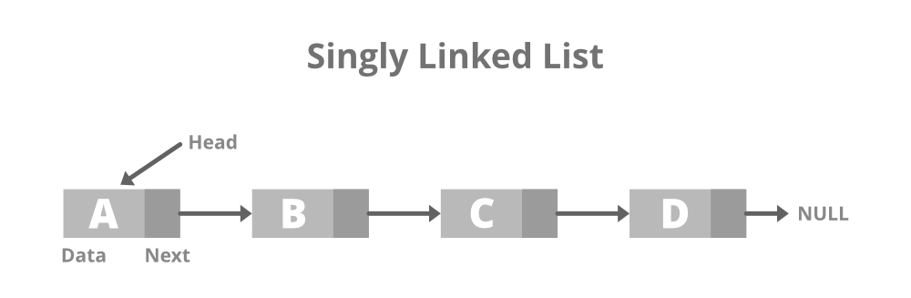

Operations to perform in single linked list are mention bellow:

1. Insert Operation
   1. Insert at beginning
   2. Insert at Position
   3. Insert at End
2. Delete Operation
   1. Delete at beginning
   2. Delete at position
   3. Delere at End
3. Traverse Operation
   1. Display items

## PROGRAMS

*#include<stdio.h>*

*#include<stdlib.h>*

*#include<conio.h>*

*// Single Linked List structure...*

*struct Node {*

*int data;*

*struct Node *next;*

*}; typedef struct Node node;*

*node *head = NULL;*

*// Function to create new node...*

*node* createNewNode(int item) {*

*node *newnode = (node*)malloc(sizeof(node));*

*newnode->data = item;*

*newnode->next = NULL;*

*return newnode;*

*}*

*// Function to insert at beginning*

*void insertAtBeg(int item) {*

*node *newnode = createNewNode(item);*

*newnode->next = head;*

*head = newnode;*

*}*

*// Function to insert at a position*

*void insertAtPos(int pos, int item) {*

*if (pos < 1) {*

*printf("\n\t\t!!! Invalid Position...\n");*

*return;*

*}*

*if (pos == 1) {*

*insertAtBeg(item);*

*return;*

*}*

*node *temp = head;*

*node *newnode = createNewNode(item);*

*for (int i = 1; i < pos - 1 && temp != NULL; i++)*

*temp = temp->next;*

*if (temp != NULL) {*

*newnode->next = temp->next;*

*temp->next = newnode;*

*} else {*

*printf("\n\t\t!!! Invalid Position...\n");*

*}*

*}*

*// Function to insert at the end*

*void insertAtEnd(int item) {*

*node *newnode = createNewNode(item);*

*if (head == NULL) head = newnode;*

*node *temp = head;*

*while (temp->next != NULL)*

*temp = temp->next;*

*temp->next = newnode;*

*}*

*// Function to delete at the beginning*

*void deleteAtBeg(){*

*if(head==NULL) printf("\n\t!!!Empty Node list...\n");*

*else head = head->next;*

*}*

*// Function to delete at position*

*void deleteAtPos(int pos){*

*if (pos < 1) {*

*printf("\n\t\t!!! Invalid Position...\n");*

*return;*

*}*

*if (pos == 1) {*

*deleteAtBeg();*

*return;*

*}*

*node *temp = head;*

*for (int i = 1; i < pos - 1 && temp != NULL; i++)*

*temp = temp->next;*

*if (temp != NULL)*

*temp->next = (temp->next)->next;*

*else {*

*printf("\n\t\t!!! Invalid Position...\n");*

*}*

*}*

*// Function to delete at end*

*void deleteAtEnd(){*

*if(head==NULL) printf("\n\t!!!Empty Node list...\n");*

*else{*

*node *temp = head;*

*while((temp->next)->next!=NULL)*

*temp = temp->next;*

*temp->next = NULL;*

*}*

*}*

*// Function to display the linked list*

*void display() {*

*node *temp = head;*

*printf("\n\tList of data:\n\t");*

*if (head == NULL) {*

*printf("\t!!! Empty Node list...\n");*

*return;*

*}*

*while (temp != NULL) {*

*printf("%d -> ", temp->data);*

*temp = temp->next;*

*}*

*printf("NULL\n");*

*}*

*// Menu-driven Dashboard*

*void Dashboard() {*

*int choice, value, pos;*

*do {*

*system("cls");*

*display();*

*printf("\n\tEnter operation: \n");*

*printf("\t\t1. Insert at Beginning\n");*

*printf("\t\t2. Insert at Position\n");*

*printf("\t\t3. Insert at End\n");*

*printf("\t\t4. Delete at Beginning\n");*

*printf("\t\t5. Delete at Position\n");*

*printf("\t\t6. Delete at End\n");*

*printf("\t\t7. Exit\n\n");*

*printf("\tEnter your choice: ");*

*scanf("%d", &choice);*

*switch (choice) {*

*case 1:*

*printf("\n\tEnter value to insert: ");*

*scanf("%d", &value);*

*insertAtBeg(value);*

*break;*

*case 2:*

*printf("\n\tEnter position: ");*

*scanf("%d", &pos);*

*printf("\tEnter value to insert: ");*

*scanf("%d", &value);*

*insertAtPos(pos, value);*

*break;*

*case 3:*

*printf("\n\tEnter value to insert: ");*

*scanf("%d", &value);*

*insertAtEnd(value);*

*break;*

*case 4:*

*deleteAtBeg();*

*break;*

*case 5:*

*printf("\n\tEnter position: ");*

*scanf("%d", &pos);*

*deleteAtPos(pos);*

*break;*

*case 6:*

*deleteAtEnd();*

*break;*

*case 7:*

*printf("\n\tExiting program...\n");*

*break;*

*default:*

*printf("\n\tInvalid choice! Please try again.\n");*

*}*

*printf("\n\tPress Enter to continue...");*

*getch();*

*} while (choice != 7);*

*}*

*int main() {*

*Dashboard();*

*return 0;*

*}*

Output:

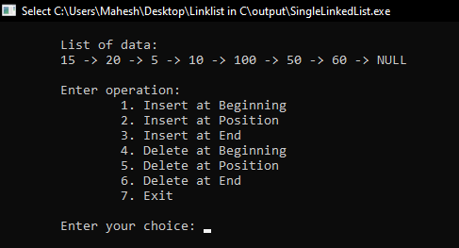 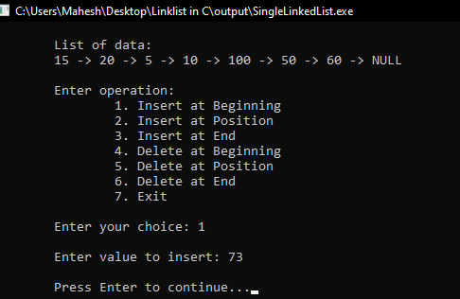

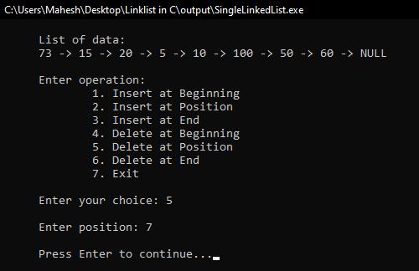 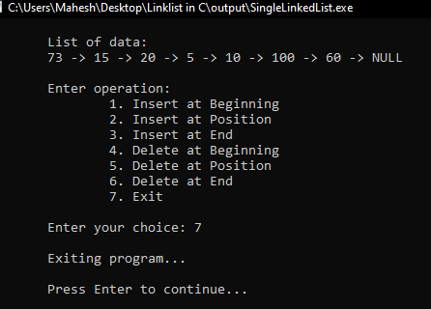

RESULTS AND DISCUSSION:

The stuents are successful to write code for single linked list in C programming. This program helps to understand basics of Data structure. The program have menu driven functioality to perform operations in single linked list.

CONCLUSION:

This laboratory exercise provided a hands-on experience in DSA. Students gained practical knowledge of implementing basic in single linked list and now better equipped to undertake more complex programming tasks in the future.